Database Lab1

4.1 How many relations are there in the Art_Course database?

Answer: 3 relations.

4.2 List the degree and cardinality of all relations

Answer:

|  |  |  |
| --- | --- | --- |
| Relation | Degree | Cardinality |
| course | 4 | 5 |
| customer | 4 | 7 |
| enrollment | 3 | 8 |

4.3 List the primary keys and foreign keys of all relations

Answer:

course

Primary key : {CourseNumber}

Foreign key : -

customer

Primary key : {CustomerNumber }

Foreign key : -

enrollment

Primary key : {CustomerNumber,CourseNumber}

Foreign key : {CustomerNumber},{CourseNumber}

4.4 Using the following SQL statement, show and discuss the results

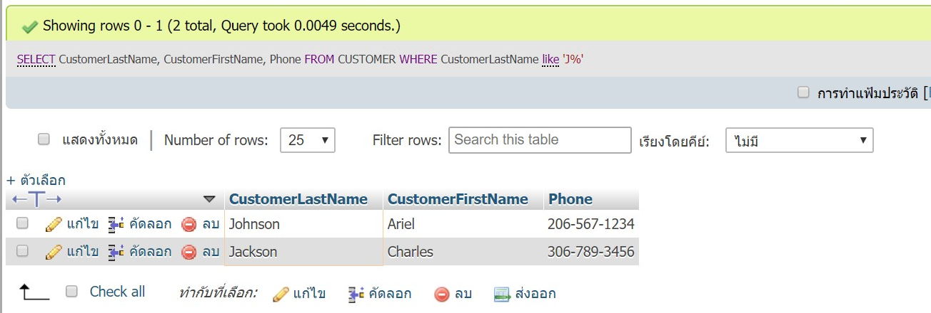อธิบาย

เป็นการดึงข้อมูล CustomerLastName, CustomerFirstName และPhone จาก customer และต้องมีCustomerLastNameขึ้นต้นด้วย ’J’ มาแสดงตามลำดับ